H.T No
Regulations:
A18

Sreenidhi Institute of Science and Technology
(An Autonomous Institution)
Code No: 7AC41 Date: 23-July-2021(AN)

B.Tech II-Year I- Semester Covid-19 Special External Examination, July-2021 (Regular)
BASIC ELECTRICAL ENGINEERING (CSE and it)

Time: 3 Hours Max.Marks:70

Note: a) No additional answer sheets will be provided.
b) All sub-parts of a question must be answered at one place only, otherwise it will not be valued.
c) Missing data can be assumed suitably.

ANSWER ANY 5 OUT OF 8 QUESTIONS. EACH QUESTION CARRIES 14 MARKS.

Bloom's Cognitive Levels of Learning (BCLL)

Remember | L1 | Apply | L3 | Evaluate | L5
Understand | L2 | Analyze | L4 | Create | L6

 |  |  | BCLL | CO(s) | Marks
1. | a) | Using superposition theorem, find the current in each branch of the network shown in Fig. below  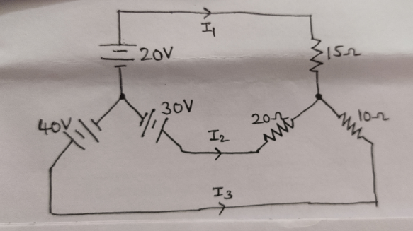 | L5 | CO1 | [7M]
 | b) | Explain about series-parallel circuits. | L2 | CO1 | [7M]
2. | a) | For the below network write directly the mesh current equation in matrix notation and hence determine I₁ and I₂  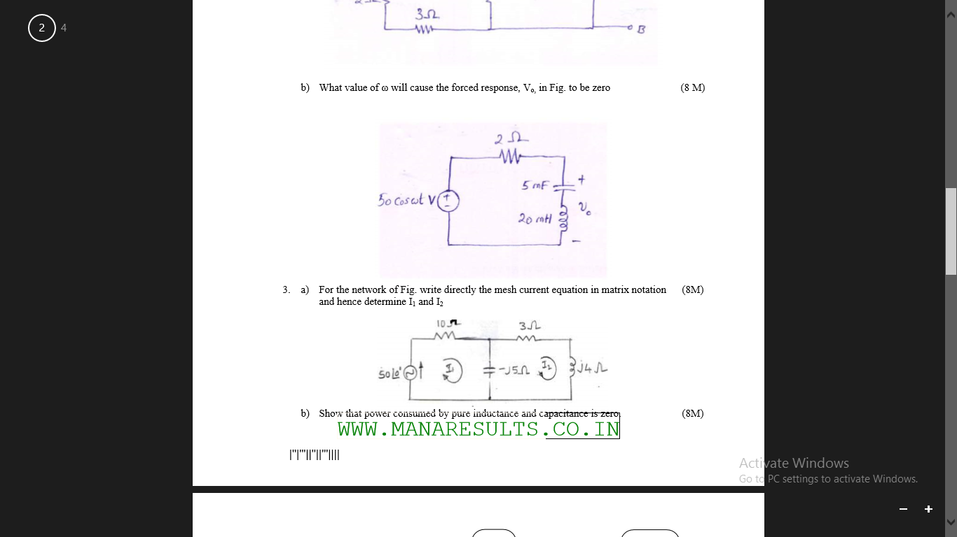 | L4 | CO2 | [7M]
 | b) | Find the Root Mean Square value, Average value, Form Factor, Peak factor for the wave form shown below. 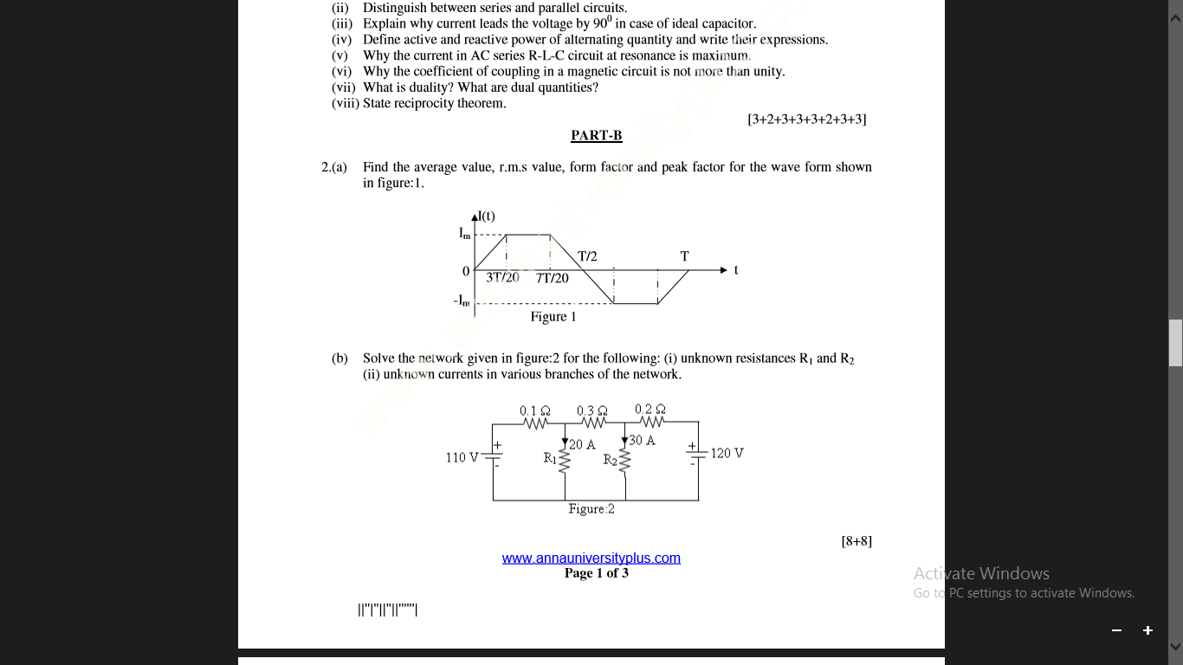 | L5 | CO2 | [7M]
3. | a) | Discuss the principle of operation of DC generators. | L3 | CO3 | [7M]
 | b) | Explain the types of DC motors. | L2 | CO3 | [7M]
4. |  | A single phase, 4KVA, 200/400 V, T/F, gave the following test result.  O.C test 200V 0.7A 60W (L.V. Side)  S.C test 9V 10A 275W (H.V Side)  (i).Draw equivalent diagram referred to L.V  (ii).Find the secondary terminal voltage at 0.8 P.F full loads.  (iii).Calculate the voltage regulation and efficiency at 65% load with 0.8 p.f. lagging | L4 | CO4 | [14M]
5. | a) | The power input to the rotor of a 440V, 50Hz, 3-phase, 6-pole induction motor is 60kW. It is observed that the rotor emf makes 90 complete cycles per minute. Calculate  (i) the slip (ii) the rotor speed  (iii) rotor copper loss and (iv) mechanical power developed. | L5 | CO5 | [7M]
 | b) | Discuss about delta connection of three phase circuits. | L3 | CO5 | [7M]
6. |  | Explain about construction features and working of Permanent magnet moving coil (PMMC) voltmeter with neat diagram? | L2 | CO6 | [14M]
7. | a) | Explain about Kirchhoff’s laws. | L2 | CO1 | [5M]
 | b) | Discuss about ac circuit containing capacitance. | L3 | CO2 | [5M]
 | c) | Show the power stages in a DC motor. | L3 | CO3 | [4M]
8. | a) | Explain the constructional details and working principle of three phase induction motor with neat sketch? | L2 | CO4 | [7M]
 | b) | A11000/230V, 150KVA, 1-phase, 50Hz transformer has core loss of 1.4kW and F.L cu loss of 1.6KW. Determine  (i) The KVA load for maximum efficiency and the value of maximum efficiency at unity p.f  (ii) The efficiency at half F.L 0.8 pf leading. | L4 | CO5 | [7M]

-- 00 -- 00 –

